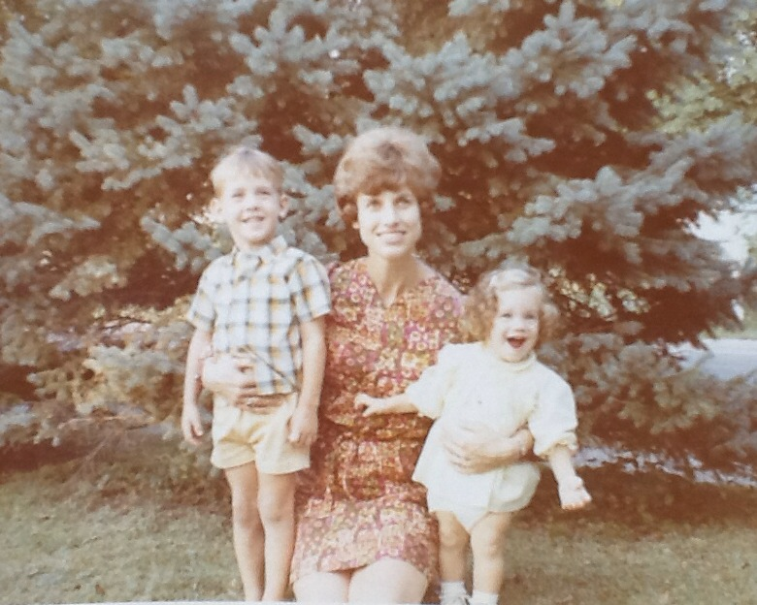

Brian, Mary Jo, and Elaine – about 1970

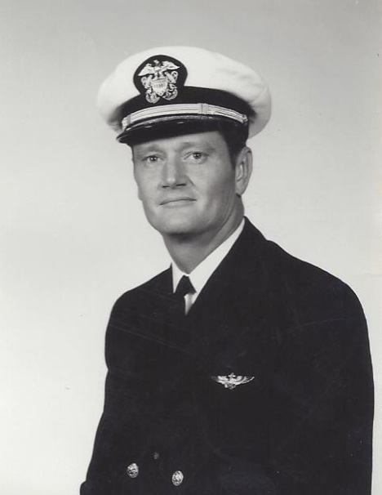

Andrew Jackson “Jack” Moore – 1972